## User Manual

1. Start the game:

- Start the game by entering `play.`. This sets the fail count to 0, resets the known characters, and displays the introductory texts.

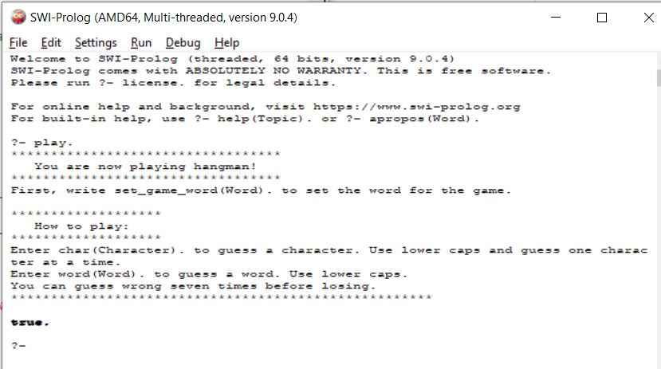

2. Set the word for the game:

-Use the predicate **set_game_word(Word).** to set the word that the user needs to guess. Replace "Word" with the desired word enclosed in single quotes.

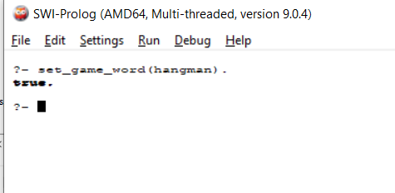

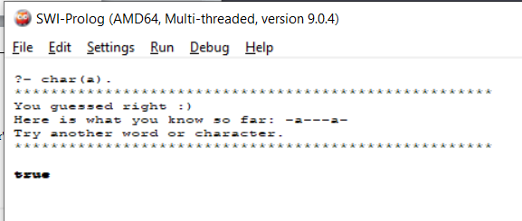3. To guess a single character, use the predicate **char(Character).**. Replace "Character" with the lowercase letter you want to guess.

4. To guess the entire word, use the predicate **word(Word).**. Replace "Word" with the entire word you want to guess in lowercase

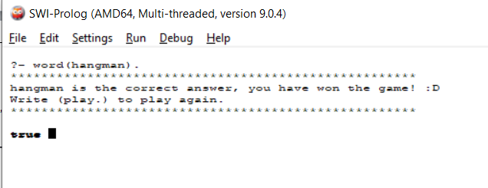

5. Additional commands:

-To display the instructions at any time, enter **help**.

-To play again after winning or losing, enter **play.**

